Product Specification Document

No. Of sprints:3

Java concepts: Collection, Exception handling, Sorting

Github link: <https://github.com/abhishek1212github/LockedMe.com--Simplilearn-Assesment-phase-1>

**Sprint :1**

Planning- Analyze, Evaluate, and prioritize all tasks in the upcoming sprint.

**Sprint :2**

Flow Chart

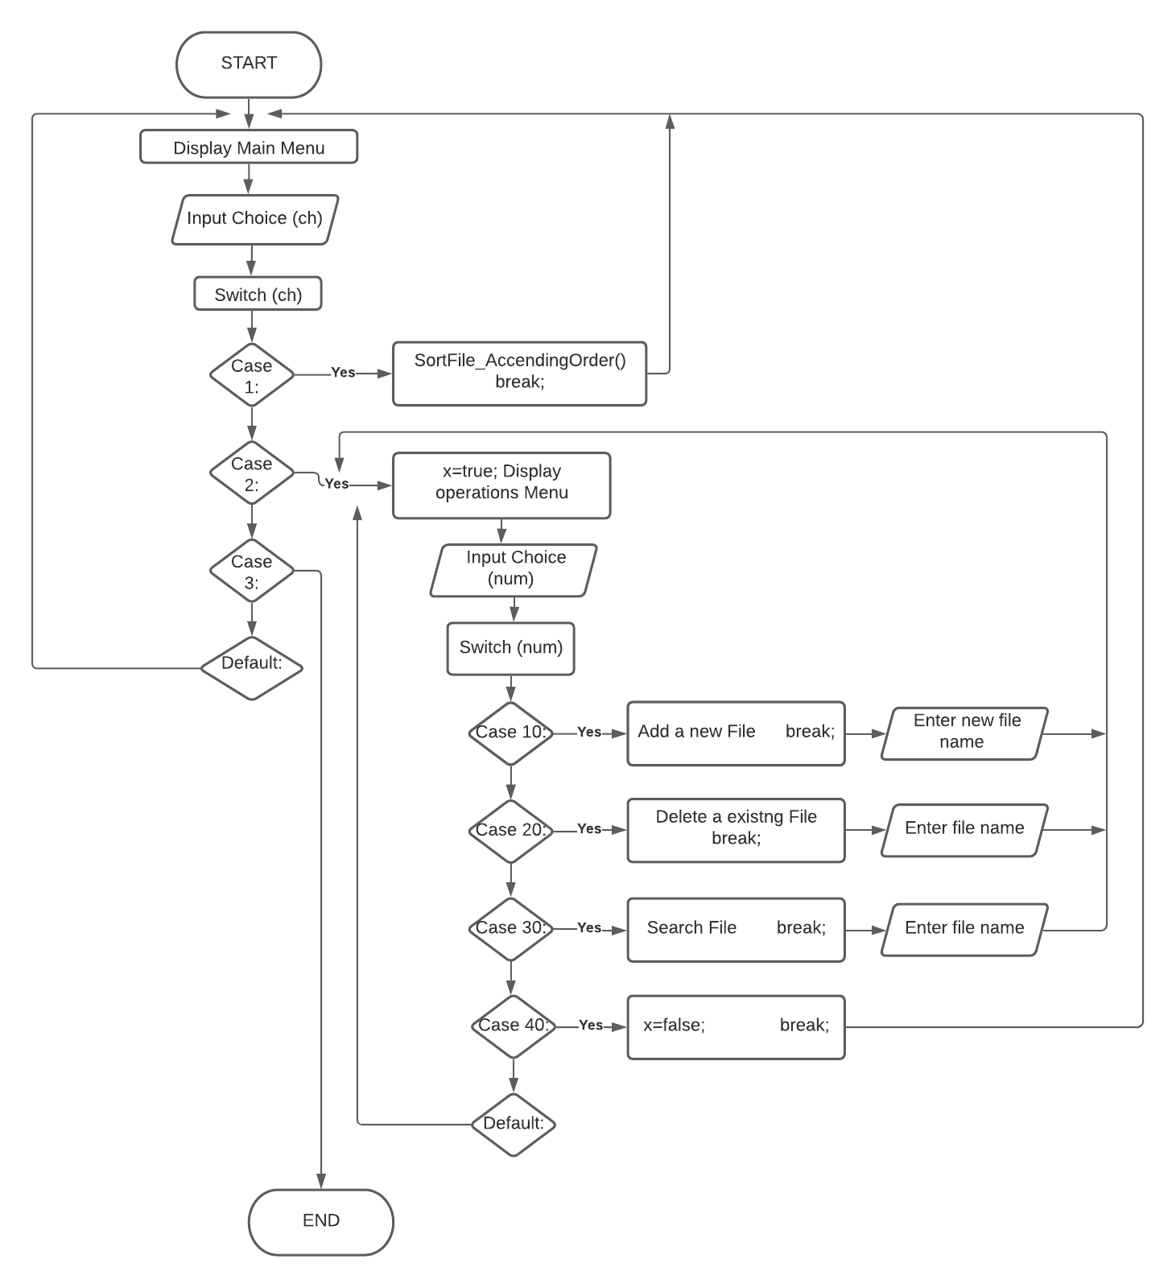

**Sprint :3**

Implementation, Testing